HACKUP TECHNOLOGY PVT. LTD.

INTERNSHIP: AI-Powered SOC & Digital Forensics

WEEK 3 — PROJECT REPORT

BY:

Vijitha S (24233)

B.SC.,CS(SSS)

PROJECT 6: MEMORY ANALYSIS
PROJECT TITLE : Students analyze memory dumps to identify suspicious processes and explain findings.

What is Memory Analysis?
Memory Analysis, also called Memory Forensics, is the process of examining a computer's RAM (Random Access Memory) to find digital evidence and investigate security incidents.
RAM stores information about running programs, user activities, and system processes. Since RAM is temporary memory, its data is lost when the computer is turned off. Therefore, memory analysis is very important during investigations.

Why is Memory Analysis Important?
Memory analysis helps investigators find:
- Running processes on the system
- Passwords and login credentials stored in memory
- Malware that runs only in memory
- Active network connections
- Clipboard contents and user activities
- Hidden malicious code and suspicious processes

Types of Memory Artifacts
- Process List – Shows all running processes.
- Network Connections – Shows active network connections and ports.
- Loaded DLLs – Shows DLL files used by processes.
- Registry Hives – Contains Windows Registry information.
- Command History – Shows commands typed in Command Prompt or PowerShell.
- Clipboard Data – Shows copied text or images.
- Injected Code – Shows malicious code injected into processes.
- Encryption Keys – Shows encryption keys stored in memory.

Memory Analysis Process
The memory analysis process includes:
- Acquisition – Capture the RAM data.
- Identification – Identify the operating system and system details.
- Analysis – Examine processes, network connections, files, and registry data.
- Detection – Find suspicious activities or malware.
- Reporting – Record and explain the findings.

Volatility 3 Overview
Volatility 3 is a popular open-source tool used for memory analysis. It can analyze memory dumps from Windows, Linux, and macOS systems.
In this project, Volatility 3 (Version 2.28.1) was used on Kali Linux to analyze the memory dump file MemoryDump_Lab1.raw and investigate system activity.

Basic Command Syntax

The basic Volatility 3 command is:
Python3 vol.py -f <memory_dump_file> <plugin_name>

Explanation
Python3 vol.py – Runs the Volatility 3 tool.
-f – Specifies the memory dump file to analyze.
Memory_dump_file – The memory image file (for example, MemoryDump_Lab1.raw).
Plugin_name – The Volatility plugin that performs a specific analysis task.

Plugins Used in This Lab

windows.info
Shows basic information about the computer, such as Windows version, system time, and architecture.

windows.pslist
Shows all programs and processes currently running on the system.

windows.netstat
Shows network connections, open ports, and connected IP addresses.

windows.cmdline
Shows the commands used to start each process.

windows.dumpfiles
Recovers files stored in memory, such as documents, images, and programs.

windows.malfind
Helps find suspicious or malicious code running in memory.

windows.hashdump
Extracts password hashes stored in memory for forensic investigation.

windows.dlllist
Shows all DLL files loaded by each process and helps identify suspicious DLLs.

Challenge Description – MemLabs Lab 1
MemLabs is a memory forensics challenge used to practice memory analysis skills.
In Lab 1: Beginner's Luck, a computer crashed, but a memory dump was recovered. Before the crash, a black command window appeared and executed something. At the same time, the user was drawing on the computer.
The goal of this challenge is to analyze the memory dump, recover important files, and find the three hidden flags.
In this project, the file MemoryDump_Lab1.raw was analyzed using Volatility 3. The investigation started by examining system information, running processes, and network connections to find clues about the hidden flags.

Challenge Information
- Challenge Name: MemLabs Lab 1 – Beginner's Luck
- Memory Dump File: MemoryDump_Lab1.raw
- File Size: Approximately 151 MiB
- Objective: Find all three hidden flags
- Tool Used: Volatility 3
- Source: MemLabs GitHub Challenge Repository

Step-by-Step Analysis

Step 1: Python Version Check
Verified Python 3.13.9 is installed on the Kali Linux system.
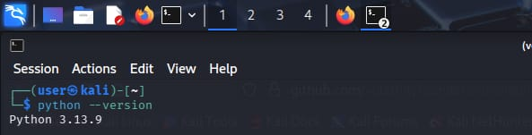

Step 2: Installing Python3 & pip
Installed python3 and python3-pip using apt package manager. Both were already at the latest version.
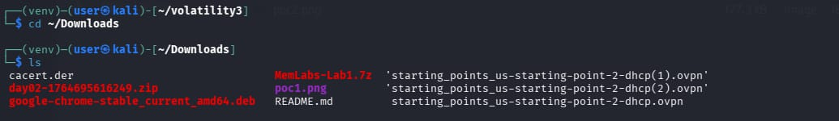

Step 3: Cloning MemLabs Repository
Cloned the MemLabs GitHub repository (stuxnet999/MemLabs) using git clone command. Total 190 objects received successfully.
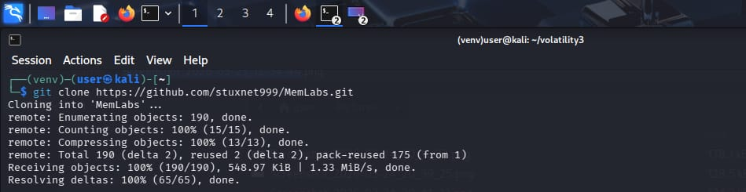

Step 4: MemLabs Lab 1 on GitHub
Navigated to the MemLabs Lab 1 folder on GitHub. The lab is titled "Beginner's Luck" and contains a README.md challenge description.
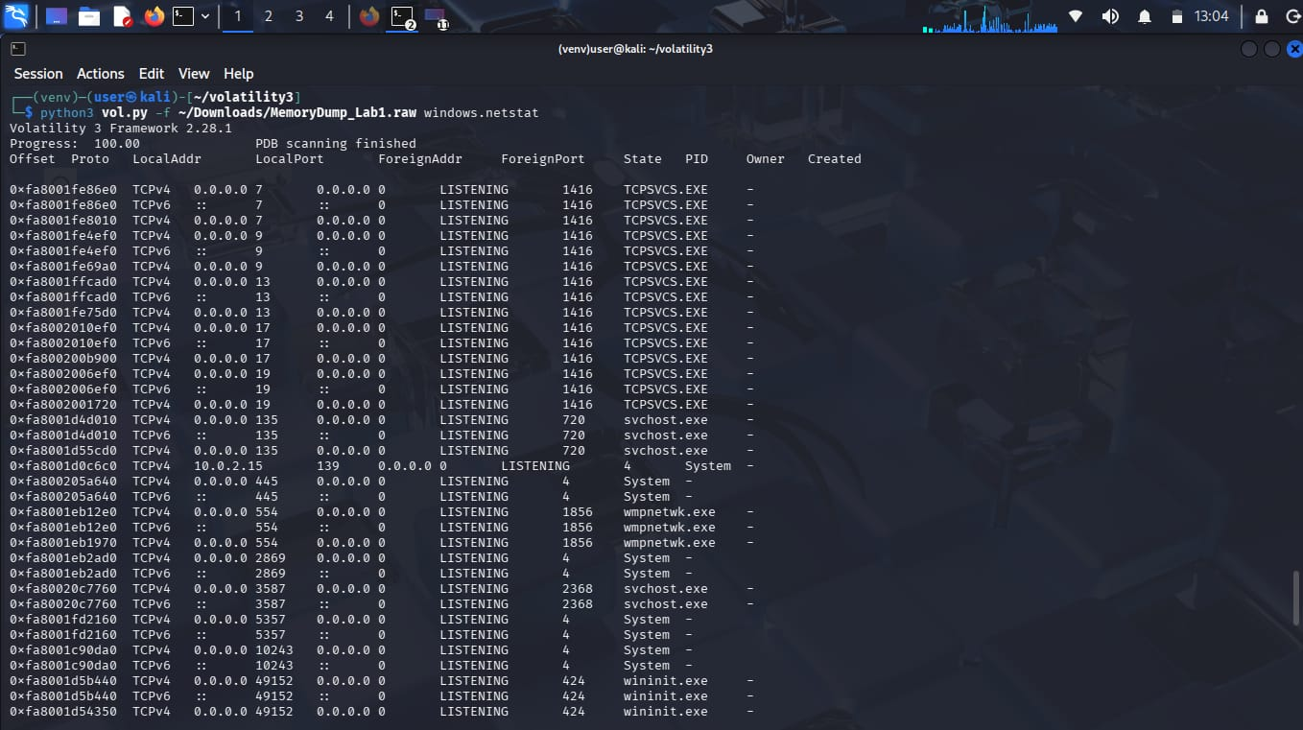

Step 5: Lab 1 README - Challenge Description
Challenge: A sister's computer crashed. The task is to recover important files from the memory dump. A black window was seen executing something before the crash. The victim was also trying to draw something.
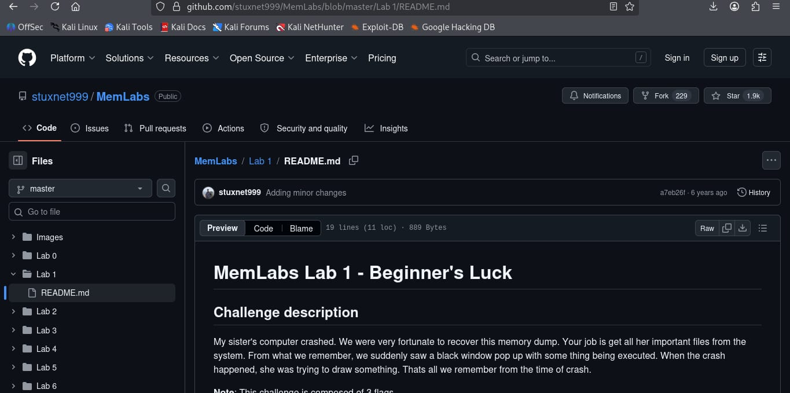

Step 6: Navigating to Lab 1 Directory
Changed directory to MemLabs/Lab 1 and listed contents. Found README.md (889 bytes, created May 25).
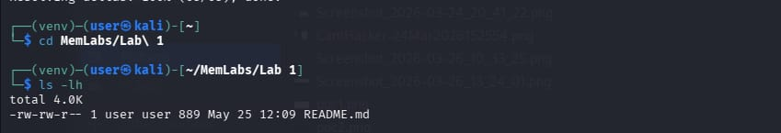

Step 7: Installing 7zip & Extracting Memory Dump
Installed p7zip-full and extracted MemLabs-Lab1.7z archive (151 MiB) using 7-Zip 26.01. The archive uses LZMA2:24 compression method.
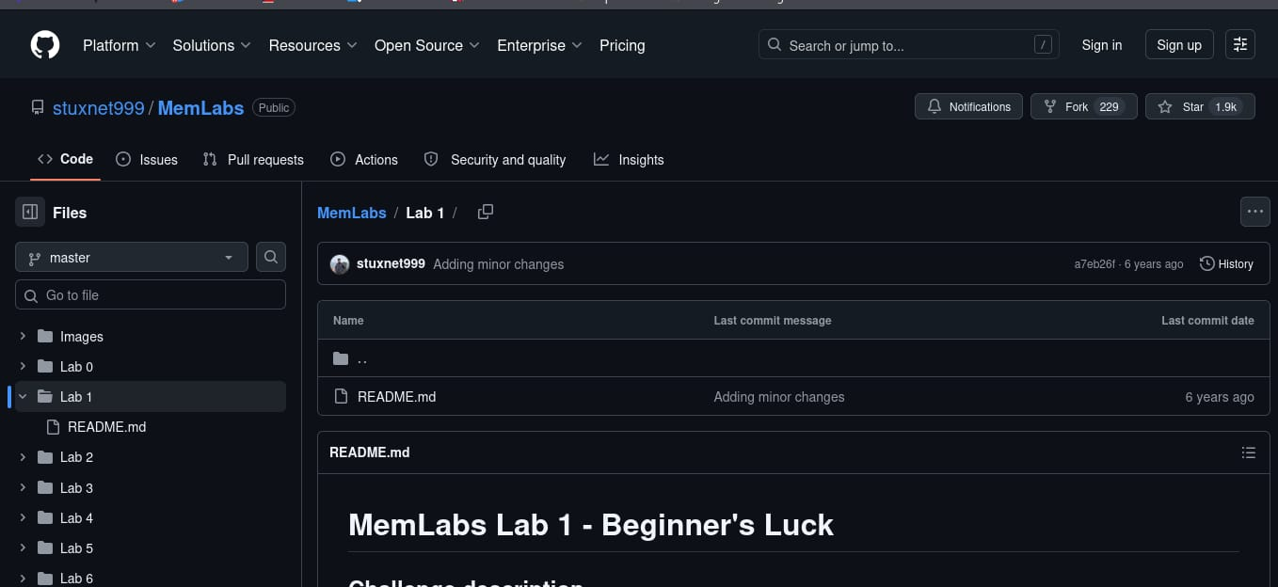

Step 8: Downloads Directory Listing
Listed files in ~/Downloads directory. MemLabs-Lab1.7z and README.md are visible along with other files.
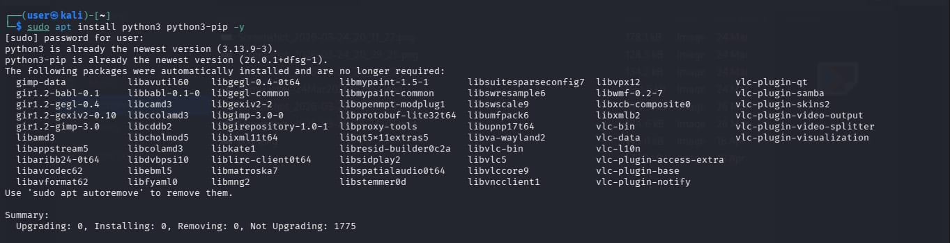

Step 9: Volatility3 - windows.info (Run 1)
Ran windows.info plugin on MemoryDump_Lab1.raw using Volatility 3 Framework 2.28.1. Identified the OS as Windows 7 SP1 (64-bit), system time: 2019-12-11 14:38:00 UTC.
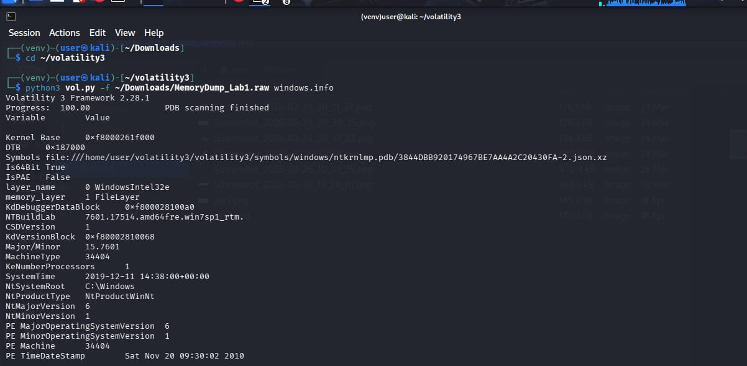

Step 10: Volatility3 - windows.info (Run 2)
Confirmed system information: NTBuildLab 7601.17514.amd64fre.win7sp1_rtm, Kernel Base 0xf8000261f000, Machine Type 34404 (x64).
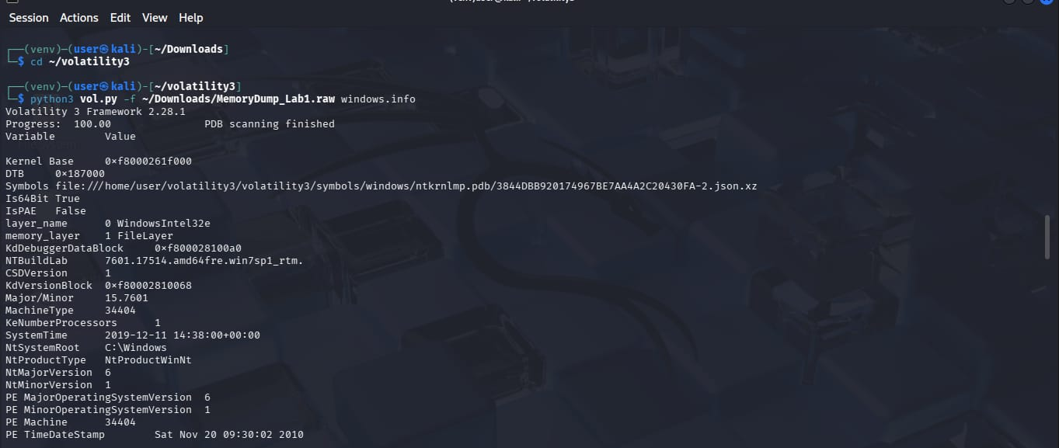

Step 11: Volatility3 - windows.pslist
Listed all running processes using windows.pslist. Key processes identified: explorer.exe (PID 604), cmd.exe (PID 1984), mspaint.exe (PID 2424), and multiple svchost.exe instances.
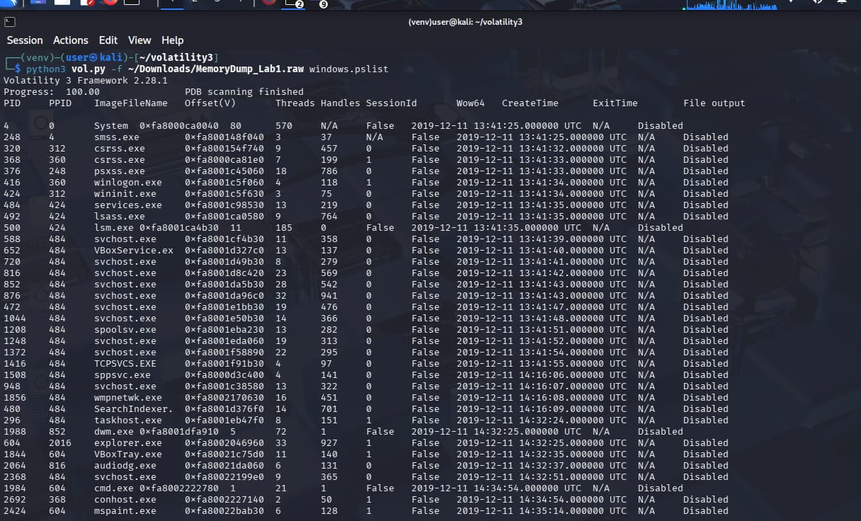

Step 12: Volatility3 - windows.netstat
Analyzed network connections using windows.netstat. Found TCPSVCS.EXE (PID 1416) listening on multiple ports, svchost.exe on ports 135 and 3587, and System on ports 445, 2869, 5357.
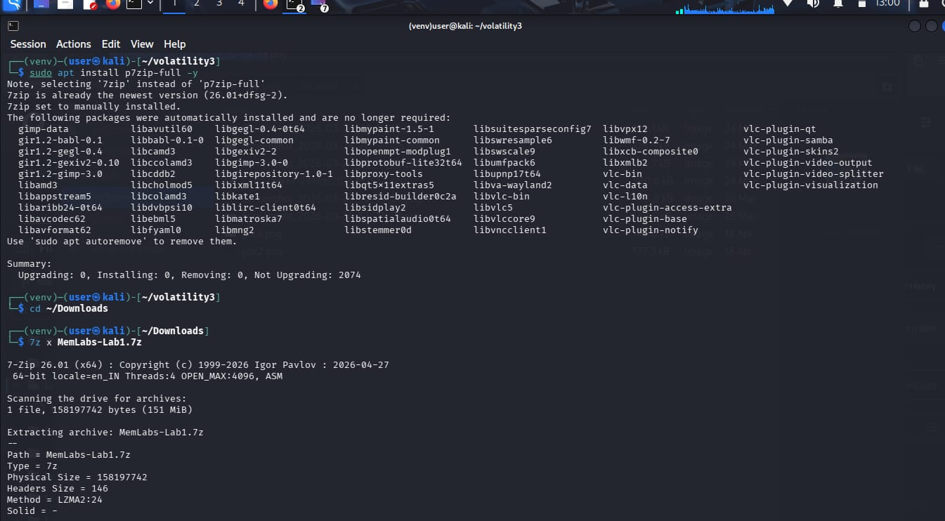

Command-by-Command Explanation

1.windows.info
The windows.info command shows basic information about the computer.
Command:
python3 vol.py -f MemoryDump_Lab1.raw windows.info

Results
- Windows 7 SP1 (64-bit)
- System time: 2019-12-11 14:38:00
- Windows folder: C:\Windows
This command helps identify the operating system and system details.

2. windows.pslist
The windows.pslist command shows all processes running when the memory dump was taken.

Command:
python3 vol.py -f MemoryDump_Lab1.raw windows.pslist

Important Processes Found
- System – Main Windows process
- explorer.exe – Windows desktop and file manager
- cmd.exe – Command Prompt
- mspaint.exe – Microsoft Paint
- VBoxService.exe – VirtualBox service
This command helps find important or suspicious processes.

3. windows.netstat
The windows.netstat command shows network connections and open ports.
Command:
python3 vol.py -f MemoryDump_Lab1.raw windows.netstat

Important Findings
- TCPSVCS.EXE was using multiple ports.
- svchost.exe was listening on port 135.
- wmpnetwk.exe was listening on port 554.
- Local IP address was 10.0.2.15.
This command helps identify network activity and suspicious connections.

Suspicious Process Analysis & Findings

After checking the processes and network connections, some important processes were found.
Cmd.exe (PID 1984)
This is the Windows Command Prompt. The challenge says a black window appeared before the crash. So, this process may contain important clues or commands related to the flag.

Mspaint.exe (PID 2424)
MS Paint was running when the computer crashed. Since the user was drawing something, an image stored in Paint may contain a hidden flag.

TCPSVCS.EXE (PID 1416)
This process was using several network ports. It looks unusual and should be checked further.

VBoxService.exe (PID 652)
This is a VirtualBox service. It shows that the memory dump came from a virtual machine.

Wmpnetwk.exe (PID 1856)
This is a Windows Media Player service. It appears normal but was included in the analysis.
Key Findings

Finding 1: cmd.exe
The black window mentioned in the challenge is likely the Command Prompt (cmd.exe). Checking its command history may help find Flag 1.

Finding 2: mspaint.exe
The user was drawing when the crash happened. An image recovered from MS Paint may contain Flag 2.

Finding 3: Network Activity
TCPSVCS.EXE was using multiple network ports. This activity is unusual and may provide useful clues.

Finding 4: Virtual Machine
VirtualBox services confirm that the system was running inside a virtual machine.

7. Summary and Conclusion
The memory dump file MemoryDump_Lab1.raw was analyzed using Volatility 3.
Main Findings
- Windows 7 SP1 was the operating system.
- The system was running in VirtualBox.
- Cmd.exe was the most suspicious process.
- Mspaint.exe may contain a hidden flag.
- Some unusual network activity was found.
- More than 30 processes were running.
Next Steps
Check commands executed in cmd.exe.
Recover files and images from memory.
Investigate mspaint.exe for hidden flags.
Analyze suspicious network activity.

Conclusion
This memory analysis helped identify important processes, network activity, and user actions. These findings provide useful clues for finding the hidden flags in the MemLabs Lab 1 challenge.

